A DISSERTION
FOR THE DEGREE OF MASTER OF ENGINEERING

Faster hologram generation by max-length depth range method

Supervising professor Nam Kim

THE GRADUATE SCHOOL
OF CHUNGBUK NATIONAL UNIVERSITY

SCHOOL OF ELECTRICAL ENGINEERING AND COMPUTER SCIENCE
MAJOR OF INFORMATION AND COMMUNICATION ENGINEERING

Md Sifatul Islam

Submitted as a dissertation

for the Degree of Master of Engineering

October 2019
APPROVED AS A QUALIFIED DISSERTATION OF MD SIFATUL ISLAM FOR THE DEGREE OF MASTER OF ENGINEERING

Chairman: Prof. Jae-Hyeong Ahn_ _____

Member: Prof. Jae-Wook Jeong ___ __

Member: Prof. Nam Kim_______ ____

THE GRADUATE SCHOOL
OF CHUNGBUK NATIONAL UNIVERSITY

October 2019
CONTENTS

CONTENTS …………………………………………………………….………. I
LIST OF FIGURES ….………………………………...…………...….….……. II
LIST OF TABLES ………………………………………………………………VI
ABBREVIATIONS………...……………………………………………………VI
ABSTRACT……………………………………………………………….……. VI
- INTRODUCTION ...........................................................................1
  - Holography
    - Holography Principles …...………………………………….………8
    - Holography Application .....................................................................9
  - Motivation....................................................................................................1
  - Thesis organization …………….................................................................3
- BASIC OF COMPUTER-GENERATED HOLOGRAPHY ...........5
  - Point cloud-based hologram ………………………………….………....13
    - Wavefront recording plane method………………………………....13
    - Multiple wavefront recording plane method………….……….…......13
  - Depth plane-based CGH ………………………………………………...13
- Proposed MLDR method
  - Background and motivation …………………………………………...13
  - Principles of proposed method…………………………….…………...13
  - Image quality analysis ………………………………………………...13
- EXPERIMENTAL VERIFICATIONS…………..........................25
  - Numerical simulations ……….…….……………………........................25
  - Optical experiments....................................................................................34
- SUMMARY AND CONCLUSION ................................…..........42
REFERENCES ......................................................................................................44
ACKNOWLEDGMENTS ...................................................................................46
LIST OF FIGURES

Figure 2.1. The basic configuration of holographic technique (a) the recording process of a hologram; (b) the reconstruction of the 3D image. ……….................... 6

LIST OF TABLES

Table 1. Measured Peak signal-to-noise ratio (PSNR) data for two objects. ....................33

ABBREVIATIONS

CGH | Computer-generated hologram
3-D | Three-dimensional
M-WRP | Multiple wavefront recording plane
WRP | Wavefront recording plane
HOEs | Holographic optical elements
AR | Augmented reality
VR | Virtual reality

Faster hologram generation by max-length depth range method

Md Sifatul Islam

School of Electrical Engineering and Computer Science
Graduate school, Chungbuk National University
Cheongju, Chungbuk 362-763, South Korea
Supervised by professor Nam Kim, Ph.D.

Abstract

In this thesis faster generation of full color computer-generated hologram (CGH) of real three-dimensional (3-D) objects is presented. A new method that uses depth information of the real objects to generate hologram faster is proposed. Conventional multiple wavefront recording planes (M-WRPs) method is one of the prominent methods for CGH generation, from point clouds, using Fresnel diffraction but reducing the distance between object points in the farthest depth layer within the depth range and the wavefront recording plane (WRP) could make it faster. This paper proposes max-length depth range (MLDR) method to create depth range of optimum length; which reduces total activate area. Thus, decreases total computation time for a CGH generation. MLDR method creates separate channels for red, green, and blue color for all object points. For each channel whole object is divided by fixed length to create temporary depth range. Next, WRP is placed in the middle of all depth layers within the temporary depth range. Proposed method is capable of around 14~34% improvement in computational time of hologram generation with almost same quality of reconstructed images compared with the conventional M-WRPs method. Feasibility of the proposed method is confirmed by numerical and optical experiments of various scenes containing multiple real objects.
CHAPTER 1.
INTRODUCTION

  - Holography
Holography was proposed by Denies Gabor in 1948 which is capable of recording and retrieving a wavefront that can store both phase and amplitude information of the original wave [1]. The term holography is derived from the Greek words “holos” and “gamma” which mean “whole” and “message”. It has the capability of recording and reconstructing an optical wavefront from an object to appear as if the object is in the same position relative to recording medium as it was when recorded [2]. Initially holography was proposed by Gabor to improve the resolution of electron microscope. In this technique both real and virtual images were reconstructed along the same direction as the reference wave, known as in-line holography. Later, in 1962, Emmett Leith and Juris Upatnieks resolved the drawback of twin images though the usage of off-axis reference beam, which is known as off-axis holography [3-5]. Leith et al created the first optical hologram using laser illumination: a toy train and bird. Soon after, Yuri Denisyuk realized that reflection hologram could be observed using spatially coherent white light source [6-7]. With reflection hologram approach, hologram is recorded on the photographic film where the reference beam and object beam lie in the same plane, arriving from two opposite directions. Onwards, most of the holograms were known as transmission holograms, which are viewed from the front by illuminating the back of the hologram with a coherent light source.
    - Holography Principles
Holography is considered as the most promising 3-D visualization technology; it can display most natural and realistic 3-D illusion to the naked eye. In conventional optical hologram coherent light source of laser of fixed wavelength is used, which create two breams: one beam acts as a reference beam and other beam interacts as the object bream. Figure 1.1 shows the process of recording a hologram.
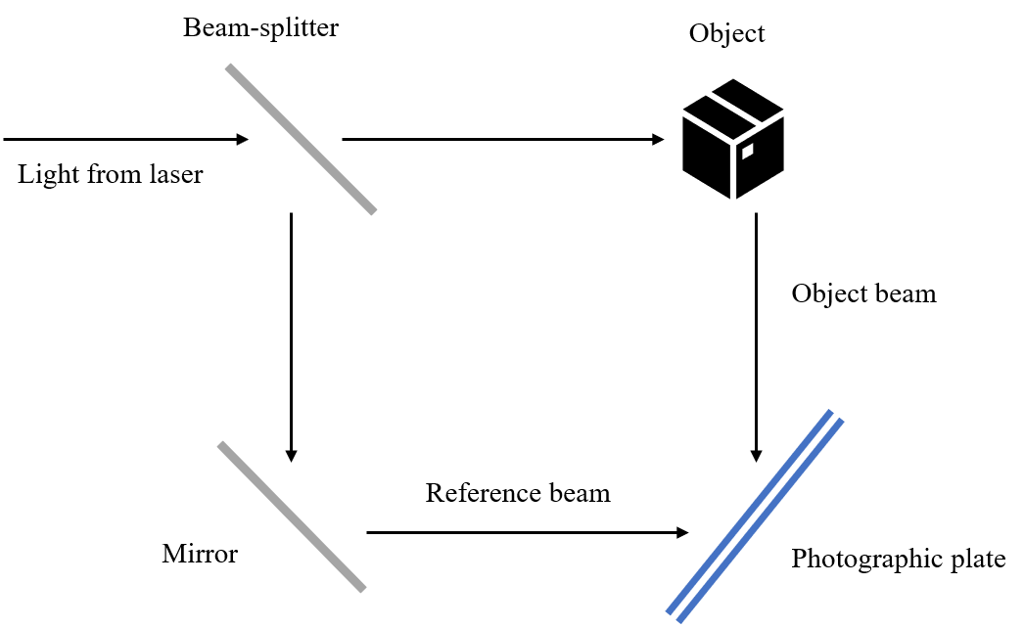
Figure 1.1 Schematic diagram of optical hologram recording process
Here, a beam-splitter splits the illuminating coherent beam from the laser into reference beam, and a separate beam for the object; which hits and reflects from the object, known as object beam, to finally combine with the reference beam on the photographic plate.
Figure 1.2 shows reconstruction of a hologram. During reconstruction of hologram, wavelength of laser needs to be same as that used in recording. When the reconstruction beam illuminates the hologram, virtual image can be seen in the same location as that of the original image.
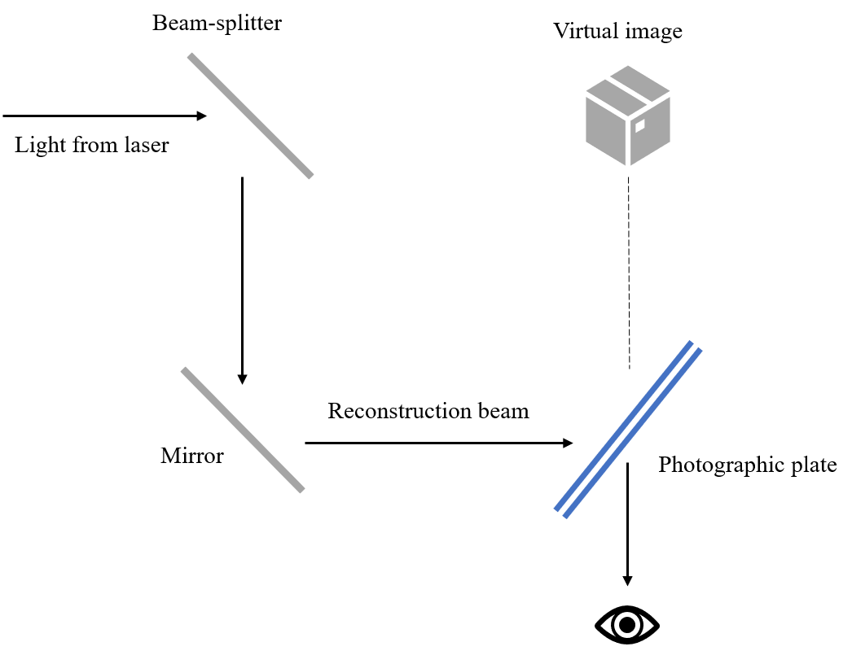
Figure 2.2 Schematic diagram of optical hologram reconstruction process
    - Holography Application
Application of holograms in real life is widely spreading from a simple display technology to data encryption-decryption, data storage and many more. With the advancement in technology data privacy concern has been growing too.
Holographic optical elements (HOEs) are widely used in trending augmented reality (AR), virtual reality (VR) technologies. Furthermore, holographic display is becoming more popular in education, or medical sectors.[1,2]
[[Chen, 2006 #2;Kim, 2004 #1], 2006 #2;Kim, 2004 #1]
  - Motivation
  - Thesis organization
CHAPTER 2.
BASIC OF COMPUTER-GENERATED HOLOGRAPHY

  - Point cloud-based hologram …………………………………….………....13
    - Wavefront recording plane method………………………………....13
    - Multiple wavefront recording plane method………….……….…......13
  - Depth plane-based CGH …………………………………………………...13

CHAPTER 3.

Proposed MLDR method

  - Background and motivation
  - Principles of proposed method
  - Image quality analysis

CHAPTER 4.
EXPERIMENTAL VERIFICATIONS

  - Numerical simulations
  - Optical experiments

CHAPTER 5.
SUMMARY AND CONCLUSION

CHAPTER 6.
REFERENCES

- D. GABOR,” A New Microscopic Principle”, Nature 161, 777–778 (1948)
- J. W. Goodman, Introduction to Fourier Optics, 2nd ed. (McGraw-Hill Book Co., New York, 1996)
- Emmett N. Leith and Juris Upatnieks, "Reconstructed Wavefronts and Communication Theory*," J. Opt. Soc. Am. 52, 1123-1130 (1962)
- Emmett N. Leith and Juris Upatnieks, "Wavefront Reconstruction with Continuous-Tone Objects*," J. Opt. Soc. Am. 53, 1377-1381 (1963)
- Emmett N. Leith and Juris Upatnieks, "Wavefront Reconstruction with Diffused Illumination and Three-Dimensional Objects*," J. Opt. Soc. Am. 54, 1295-1301 (1964)
- Yu. N. Denisyuk, Proc. SPIE 1600, 376 (1991).
- Yu. N. Denisyuk, “Imaging properties of light intensity waves: the development of the initial Lippmann ideas”,J. Optics (Paris), 22, 275 (1991)

CHAPTER 7
ACKNOWLEDGMENTS

